# 

New In-Country Site

Moving An Existing ASP Site In-Country

# New In-Country Site

Note: if you are moving an existing site that has been using the ASP (Application Service Provider) Server (<https://haiti.cirg.washington.edu/isante/> jump to the section **Moving An Existing ASP Site In-Country** below.

1. Steps on the Port Au Prince consolidated (coordinating) server:

A. Log on to the PaP site:

<https://isante.ugp.ht/consolidatedId/isante>

B. Search for the site using the menu item ***Entretien des cliniques de iSanté*** on the consolidated server:

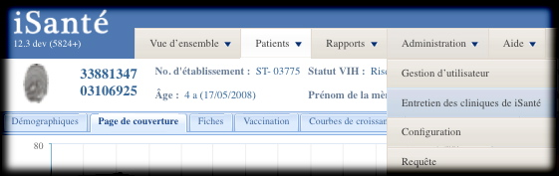

C. Select the site and assign additional site attributes with the button **Éditez l'etablissement**. In particular, it is required that you select a dbsite value for in-country sites. Make note of **sitecode** and selected **dbsite** value and fill in the site’s **hostname** and **IP address**, if known.

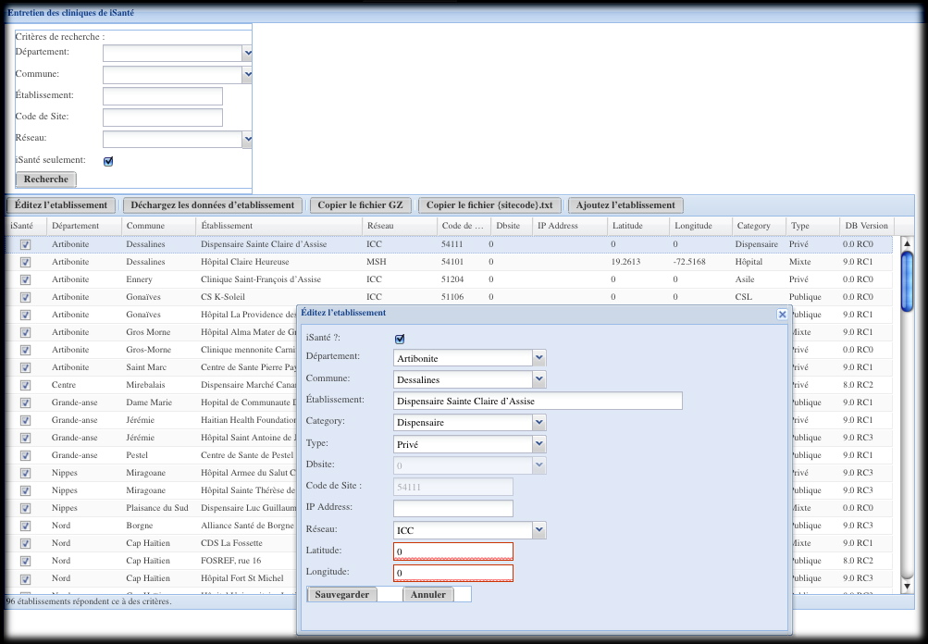

3. Install the site's on-site server.

4. Install iSanté and OpenELIS as specified in their respective installation guides, providing **sitecode** and **dbsite** values when asked.

# 

# Moving An Existing ASP Site In-Country

1. Establish a "cut-off date," which is the last day that the site enters data to the ASP server. This should be negotiated with the on-site clinical personnel.

2. One day after the cut-off date, on the Port Au Prince consolidated (coordinating) server:

A. Log on to the PaP site:

<https://isante.ugp.ht/consolidatedId/isante>

Verify that all work done as of the cut-off date has been replicated to the consolidated server. If not, wait another day.

B. Search for the site using the menu item ***Entretien des cliniques de iSanté*** on the consolidated server:



C. Select the site and assign additional site attributes with the button **Éditez l'etablissement**. In particular, it is required that you select a **dbsite** value for in-country sites. Make note of **sitecode** and the selected **dbsite** value and fill in the site’s **hostname** and **IP address**, if known.



D. Unload the site’s data with the button **Déchargez les données d'etablissement**. The data file is automatically placed on the server here:

/var/backups/itech/unloads/

After a successful unload, the above directory should contain the following files:

{sitecode}errors.txt contains any errors during the unload (should be zero size)

{sitecode}.txt summarizes the data unloaded

{sitecode}.csv.gz contains the site’s data

where {sitecode} represents the actual **sitecode** value (i.e. HUEH is 11100) for the site.

{sitecode}.csv.gz will be used to load the site’s new server in step 6) below.

3. Install the site's on-site server.

4. Install iSanté and OpenELIS as specified in their respective installation guides, providing the **sitecode** and **dbsite** values when asked. **IMPORTANT: when moving an ASP site in-country, it is essential that the most recent version of iSanté be installed. If this is not done, there is the possibility of data loss.** Obtain the most recent iSanté version here:

haiti01@almond.cirg.washington.edu

5. Copy the unloaded {sitecode}.csv.gz file from the consolidated server location above so that it can be applied to the new server. You can copy the {sitecode}.csv.gz file to your client computer using the **Copier le fichier GZ** button, but please wait long enough be sure it is completely unloaded before copying. For comparison purposes later, also copy the unload statistics file {sitecode}.txt, using the button **Copier le fichier {sitecode}.txt**.

6. While logged on to the new server, load the new server with the site’s data:

sudo sh

cd /var/www/isante/replication

perl updateTarget.pl --file {sitecode}.csv.gz > {sitecode}.txt 2> {sitecode}errors.txt

This load process could take some time, particularly for a site with more than 200 patients.

7. Verify that the load was successful by comparing the {sitecode}.txt file generated on the consolidated site in step 2.D) with the {sitecode}.txt file generated in step 6).